Template for the DS Assignment 2 – part 2

Please note that you can modify this template to suit your own presentation

This is only a sample, you should make sure all aspects of your work and assessment tasks are clearly evidenced

You should check Assignment Deliverables and the marking schema.

Take screenshots showing clearly:

- Student id in Apex account
- Apex 5 – university www address
- Time and date on your machine
E.g.
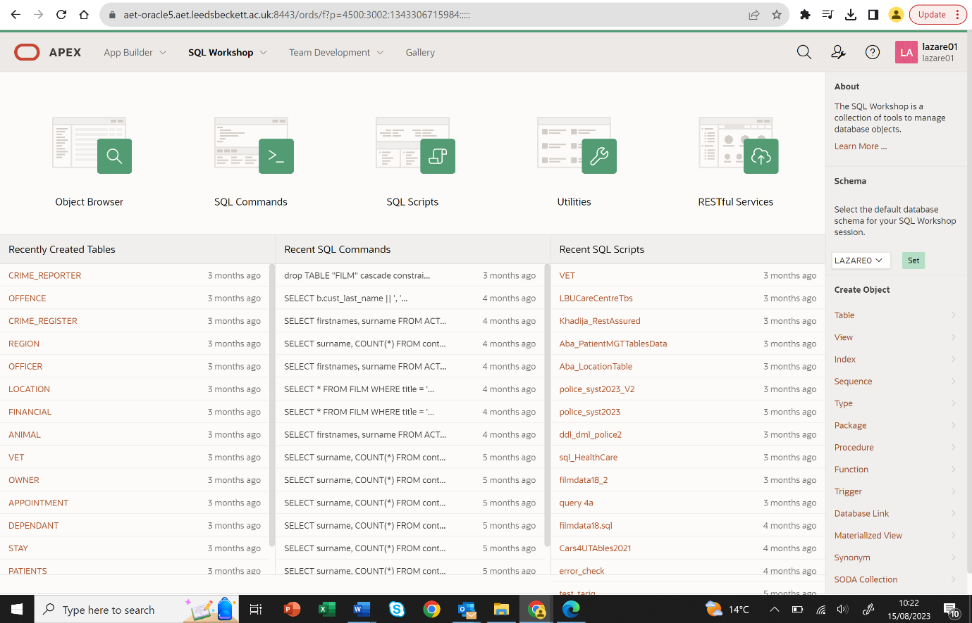
2
1
3
Title:
Module Name:
Student Name:
Student id:

Before you start, read Assessment Guide carefully. Check Marking schema and Assignment Deliverables.

Task 5. Application Builder Forms

Example: Forms Page (note yours should be Master/Detail)
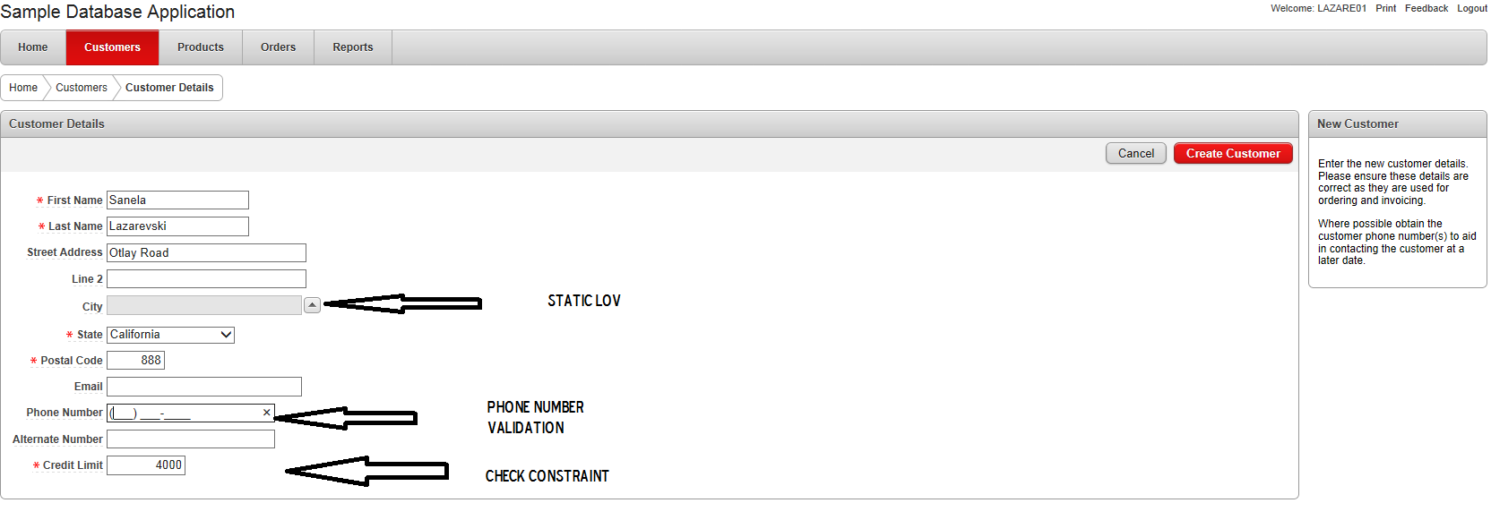
Discuss your additional features you have implemented on this page. For example this page has got LOVs for City, State. Validation on Phone number column, credit rate has got check for value =< 5000 etc..
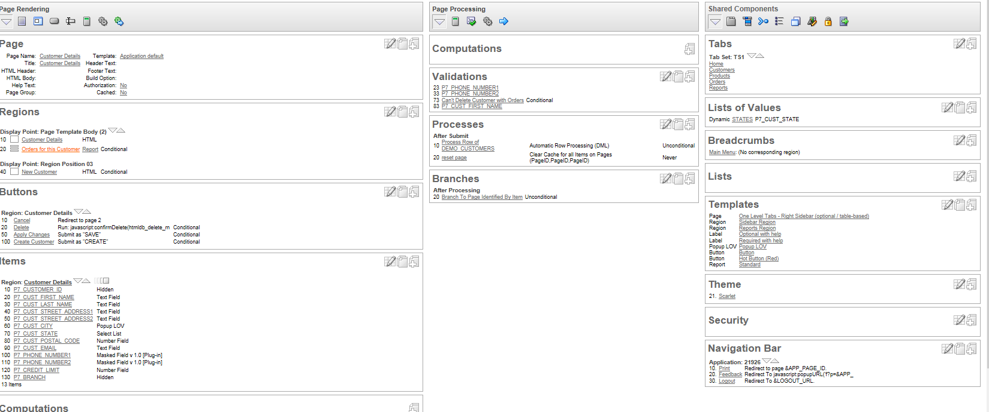

INSERT: A new customer record inserted:
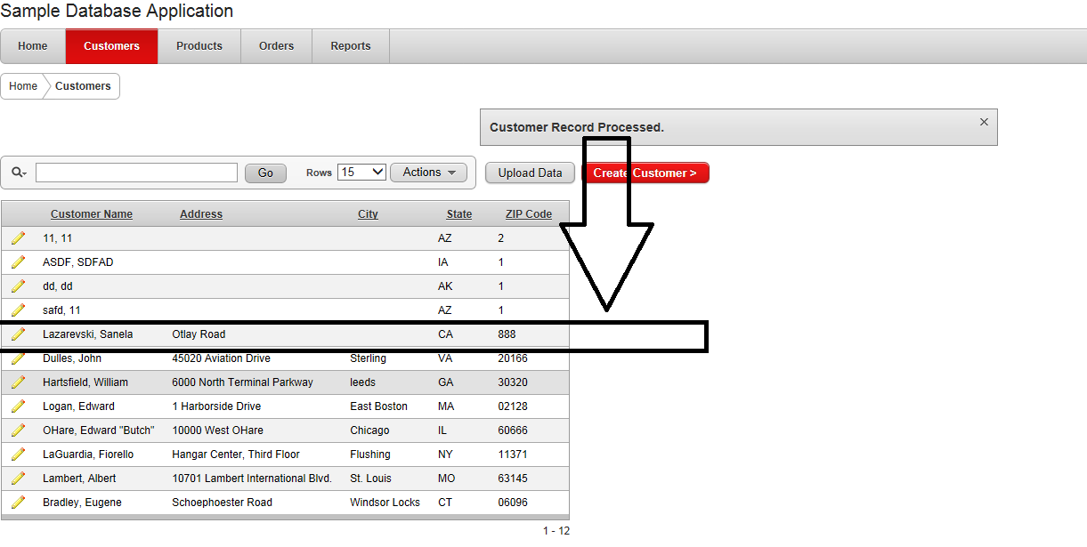
Have you implemented a message or modified default message to confirm record has been created?

DELETE: e.g. a customer record has been deleted:

Screen shot xxx

UPDATE: e.g. a customer record has been changed:
Screen shot xxx

Apex Features: LOV, Dynamic Actions, Validation
Screen shots xxx
Screen shots xxx
Screen shots xxx
Screen shots xxx

Note that this is just to help you structure your assignment, much more detail is required. Please read the assessment guide for all details.

4. Bibliography

Harvard style

5. Appendixes

…

